Steps:

1. Upload single or multiple files from the input screen
2. Give search string or pattern
3. Select method and execute

Output:

1. Search “Swimming” in 4 files,

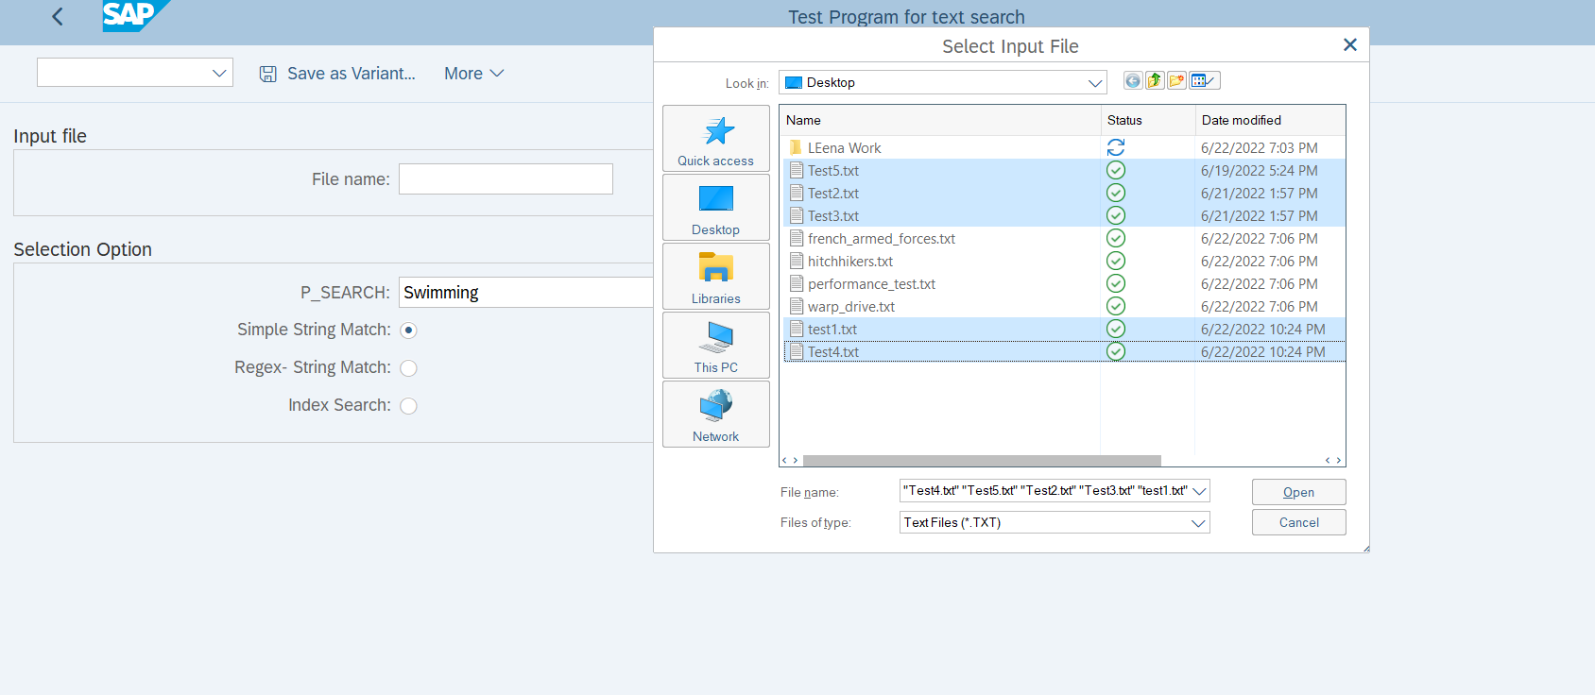

1. o/p: total elapsed time for all the files on the search term (test 5.txt is empty )

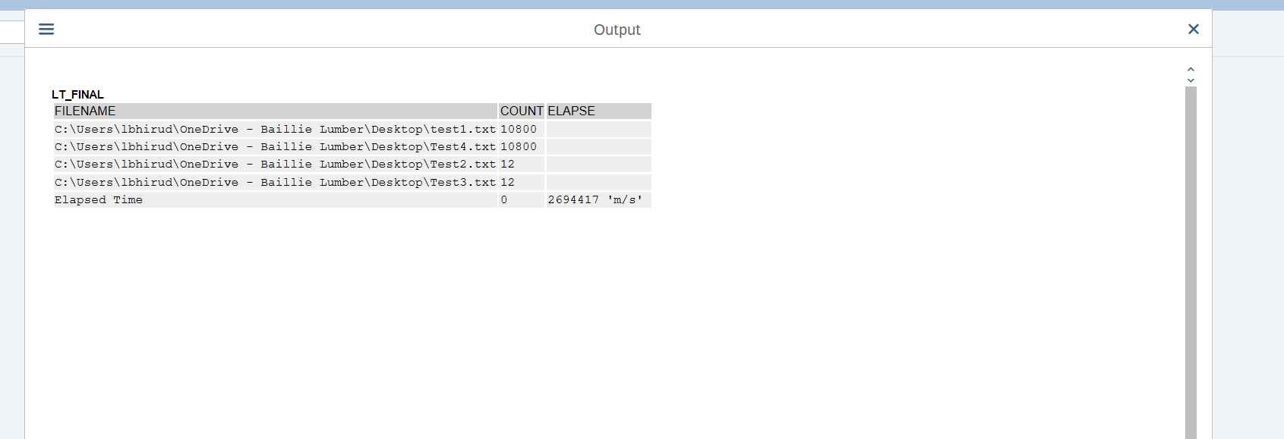

1. Search for a pattern in 5 files

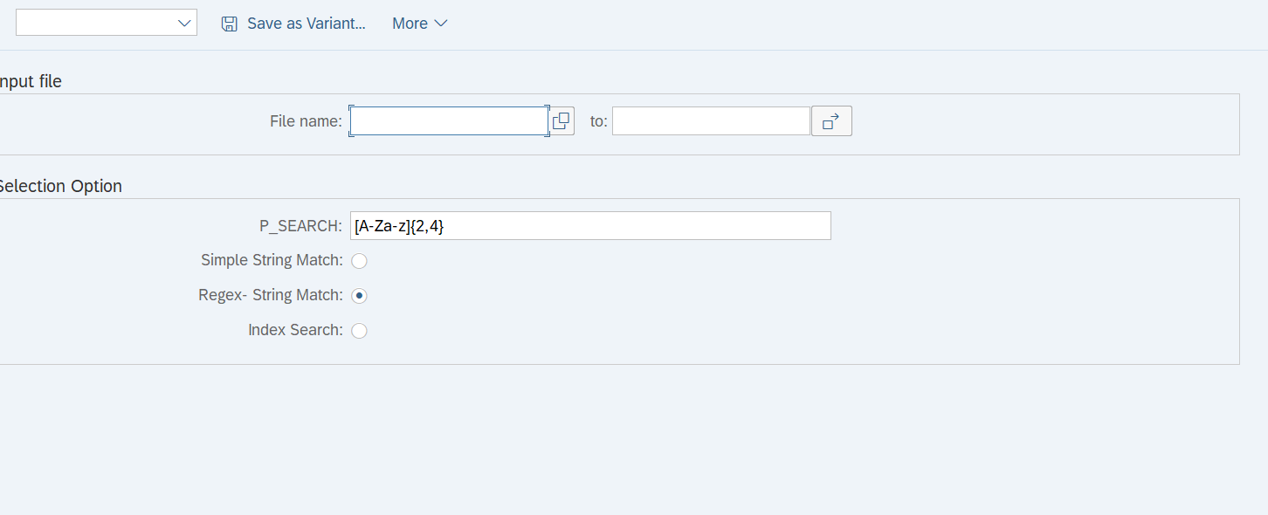

1. o/p: total elapsed time for all the files on the search pattern

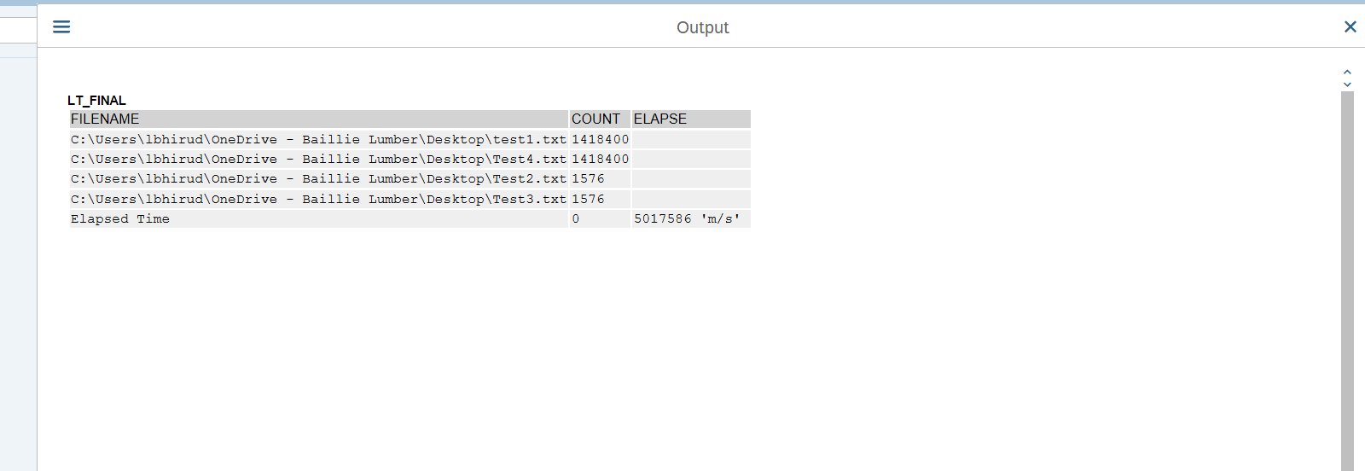

1. o/p : pre-processed files using index

Method 1&2: The complexity for string matching and regex is O(N).

Method 3 The complexity for string matching and regex is O(1).

Design Scaling:

1. Use parallel processing: to handle large-size files in further code

Read file using Function module then divide the internal table into small chunks ex If file size >100MB then using package size divide the internal table in sub internal tables a process them in the background using RFC

1. Using SAP HANA modeler

Import text file to Hana modeler and load data into a table with two columns ID, Text_line then create a full-text index on the created table, perform search operation providing search string

1. Perform index on file contents in python and call the .py file to sap using the python connector